Business Process Document (BPD)

SAP ARIBA Sourcing

Version History

|  |  |  |  |  |
| --- | --- | --- | --- | --- |
| Version | Date | Author | Reviewer | Update / Change Details |
| 0.1 |  |  |  |  |
|  |  |  |  |  |

Contents

1. Introduction 4

1.1 Objective 4

1.2 Sign Off Parties 4

1.3 Business Blueprint Document (BPD) Change Governance 4

2. Introduction- SAP ARIBA 7

3. ARIBA Process Overview 7

4. SAP Ariba Sourcing - TO BE Process 8

4.1 Process Flow Diagram: 8

4.2 Sourcing Process Explanation: 10

5. Requirement Points: 13

6. Templates: 13

7. ADDENDUM 14

8. APPENDIX 15

8.1 Parking Lot Items from Workshop Process Walkthroughs 15

1. Introduction
   1. Objective

This document describes the key business processes for SAP Ariba Sourcing and the related enterprise structure definitions. This document is intended to provide a holistic view of all the key elements of the design including organisation/roles, technology, process and data requirements in a format and language that is appropriate for business review and sign-off.

The sign-off of this document concludes the Design Phase and serves as inputs to the Build / Test Phase.

* 1. Sign Off Parties

Key business representatives and process owners from:

* XX Business Process Owners (BPOs)
* XX Business Process Leads (BPLs)
* XX Technology Leads (IT)
  1. Business Blueprint Document (BPD) Change Governance

Below is the process that will be followed to track the updates to the document:

* The BPDs are initially released as v0.1. This version takes the Singapore specific BPD (Process Design Document) as a baseline.
* All amendments made to the BPD henceforth, as part of the design phase and during review sessions will be captured as new versions incrementing by 0.1 (e.g. v0.1, v0.2, and so on).
* When the version is ready to be issued for sign-off, the version should be raised to the next whole number. For e.g., if the current version is at v0.6 and it is ready of sign-off, the version would be raised to 1.0 and Revision History section should be updated with the comments “Issued for sign-off’.
* **Standards for file name format:**

*<Client Name>_<Project Name>_<Doc Type>_<Module>_<Function>_<Description>_<Version>*

*Example:*

*XX-Project-Comet-BPD_SAP ARIBA_Sourcing_v1.0.docx*

**Client Name:** Keppel

**Project Name:** XX Comet

**Doc Type:** Defines the type of document

|  |  |
| --- | --- |
| ID | Description |
| BPD | Business Blueprint Document |
| BPD | Local Design Document |
| FDD | Functional Design Document |
| TDD | Technical Design Document |
| UTP | Unit Test Procedure |
| SIT | System Integration Test |
| UAT | User Acceptance Test |
| OCM | Organisational Change Management |
| DM | Data Migration |

**Module:** Identifies the relevant modules in SAP/ARIBA/KYRIBA.

|  |  |
| --- | --- |
| ID | Description |
| FI | Finance (SAP) |
| MM | Materials Management (SAP) |
| PS | Project System (SAP) |
| ARIBA | Ariba (SAP) |
| TR | Treasury (Kyriba) |

**Function:** Identifies the relevant sub-modules in SAP/ARIBA/KYRIBA.

|  |  |
| --- | --- |
| ID | Description |
| CO | Controlling (SAP) |
| AR | Accounts Receivable (SAP) |
| AP | Accounts Payable (SAP) |
| GL | General Ledger (SAP) |
| AA | Asset Accounting (SAP) |
| PU | Procurement (SAP) |
| IM | Inventory Management (SAP) |
| SLP | Supplier Lifecycle Management (ARIBA) |
| SR | Sourcing (ARIBA) |
| CA | Commence Automation (ARIBA) |
| BA | Bank Account Management (Kyriba) |
| BS | Bank Statement (Kyriba) |
| FINS | Financial Transactions (Kyriba) |
| PAY | Payment Factory (Kyriba) |
| REC | GL Reconciliation (Kyriba) |
| CMF | Cash Management and Forecast (Kyriba) |
| CA | Cash Accounting (Kyriba) |

1. Introduction- SAP ARIBA

Ariba Sourcing is used to source goods and services across different categories. This module allows entities to conduct their sourcing event from start to end, including creating and posting documents, receiving electronic responses, and finding the winning supplier. The sourcing events include forward and reverse auctions, Request for Information, Request for Proposals, etc. Through the sourcing module, entities are also able to leverage the Ariba Network and Ariba Discovery to increase and promote competition among more suppliers.

SAP Ariba is an online solution catered to delivering a cloud-based procurement platform for the needs of both buyers and suppliers. It is touted as one of the world’s leading business commerce networks where businesses of all sizes can connect to their trading partners anywhere, at any time, and from any application or device to buy, sell, and manage their cash more efficiently than before.

1. ARIBA Process Overview

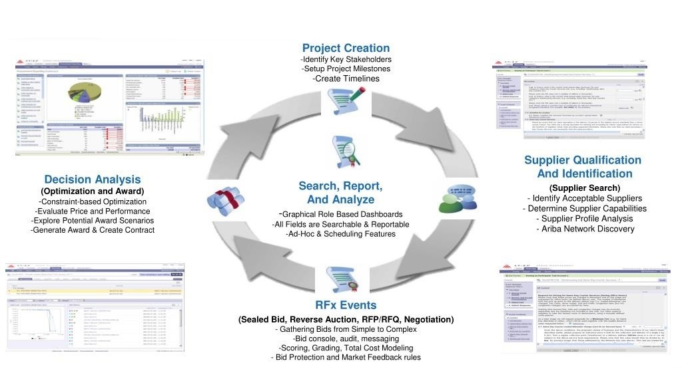

1. SAP Ariba Sourcing - TO BE Process
   1. Process Flow Diagram:

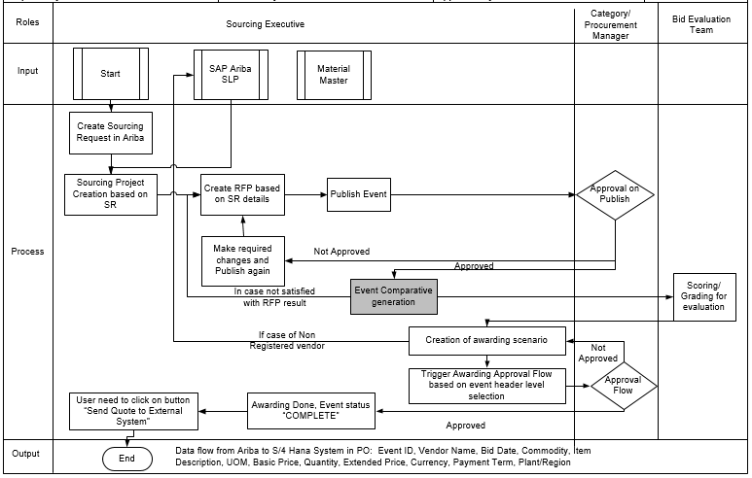

|  |  |  |  |  |
| --- | --- | --- | --- | --- |
| Sr No | Process Tasks | Role | Description | Mode |
|  | Sourcing Request Creation | User | In Ariba Sourcing Request will be created by Sourcing Executive | Ariba User Portal |
|  | Souring Project Creation | Sourcing Executive | Sourcing Project will be created based on information in Sourcing Request | Ariba User Portal |
|  | Create Sourcing Event | Sourcing Executive | Sourcing executive will create the event in Ariba based on the requirements. | Ariba User Portal |
| 4. | RFP Creation | Sourcing Executive | Create RFP based on the requirements and choose appropriate template. Publish/Awarding approval flow will be based of template selection and choose header level fields during event creation. | Ariba User Portal |
| 5. | RFP Comparative Generation | Sourcing Executive | Get the response in RFP and download system generated comparative | Ariba User Portal |
| 6. | Awarding Scenario | Sourcing Executive | Awarding Scenario is created by buyer as per the need | Ariba User |
| 7. | Supplier Registration if added vendor is not registered | Sourcing Executive/ Supplier Registration Manager | If non-registered supplier is added in sourcing event, then supplier registration process will be initiated by sourcing executive with help of supplier registration manager | Ariba User |
| 8. | Approval Flow Trigger | Sourcing Executive | Sourcing executive will click on submit tab and process approval flow will execute as per the provided requirement | Ariba User |
| 9. | Sending award for approval | Awarding Approver | Email regarding approval will trigger to concern persons | Ariba Award Approver |
| 10. | Approval on Award | Awarding Approver | After getting approval (approval as per put at template) event status become complete. Once status complete no change is possible in event. | Ariba Award Approver |
| 11. | Final details sent to S/4 Hana | Sourcing Executive | To send the event details in ERP, sourcing executive need to click on button "send quote to external system" | Ariba User Portal |
| 12. | PO Creation | Automatic | PO will be created in S/4Hana based on awarded details from Ariba | S/4Hana |
| 13. | Update regarding PO Creation | Automatic | Once PO is created successfully/failed, details will be updated in sourcing event log | Ariba User Portal |

* **Sourcing Executive/Buyer**- The person who is responsible for creating, publishing and monitoring the event. These personals are license user.
* **Approver**- The person who is a part of publishing and awarding approval flow.
* **Supplier**- Person or vendors who are invited to provide the prices for requirement published by the buyer
  1. Sourcing Process Explanation:

The process has been explained as below:

* Sourcing Request will be created by User in SAP Ariba
* Souring Executive will open the Souring Request and create Sourcing Project:

1. Full Project – include one or more sourcing events and include full project management features and tasks
2. Quick Project – are single sourcing events i.e. RFI, RFP and Auction:

|  |  |
| --- | --- |
| RFI | An RFI event is used to gather non-competitive data, information, comments, or reactions from potential participants. Participants typically do not respond to an RFI with pricing information. Instead, RFIs usually precede other events (RFPs or auctions) that include price |
| RFP | Request for Proposal (RFPs) can collect pricing information. You generally start allowing responses as soon as the event is published, unless you think it likely that you will need to edit the event as a result of supplier feedback |
| Auction | An auction is usually a process of buying and selling goods or services by offering them up for bid, taking bids, and then selling the item to the highest bidder or buying the item from the lowest bidder. There is different type of Auction formats i.e. Reverse, Forward etc. |

* During event creation buyer will choose an appropriate template for event creation.
* Event creation comprises of below steps:
  1. **Rules:** Event rules control how the events works. When creating a template, you often have the option to withhold control of this rule from the person who is using the template to create an event, also known as the Project Owner. The options are:
* **Delegated:** The ability to edit this rule is delegated to project owners. When they create a project, they can see this rule and they can see this rule and they can change the setting.
* **Read Only:** When they create a project, project owners can see this rule and setting, but cannot edit it.
* **Hidden:** When they create a project, project owners cannot see this rule or how it is set.

Below are the Rules which need to be defined by Buyer in Draft stage of event:

* **Timing Rule-** Rules control event timing, bidding periods, preview periods, and review periods. These are some usage considerations for timing.
* **Bidding Rule-** These are essentially bid-improvement rules: participants are bound by their bids and can only revise them by improving them. With these bidding rules, SAP Ariba Sourcing gives you additional power to determine exactly how participants in your events must improve their bids. It is common to specify a common set of bidding rules for all lines and lots in an event with line-item-specific price decrements. However, if desired you can configure lot or line item specific bidding rules.
* **Currency Rules-** This rule allows participants to select the currency in which they place their bids and we can choose to allow participants select the bidding currency.
* **Market Feedback-** Change the setting of these rules to expose information about the participants in your event and their pricing.
  1. **Team:** In team tab buyer add team member for the event, whom they want to involve in the event
  2. **Supplier:** When buyer selects the region and commodity on header level, based on same, on search filter page buyer can only find the suppliers of selected header fields after clicking on Invite participant page.
  3. **Content:** All RFQ line items would be replicated as line item automatically in this section, if buyer want, they can add questions, attachments etc. for better understanding of the requirement. Buyer can also add content/document from Sourcing Library predefined. Sourcing Library is a functionality which is used as repository of the documents.
  4. **Summary:** Buyer can overview all the information and publish the event.
* If any approval flow is applied at the template level on publish, it will execute automatically, or buyers can add approval flow or Publish event manually.
* An email will trigger to all the invited suppliers for participation.
* Supplier can login and respond to the event by selecting the lots as defined by buyer within prescribed time frame.
* Buyer can observe how many suppliers are online and their respective status (Invited, Accepted Agreement, Intend to Participate, and Participated) in an event.
* Buyer and Supplier can communicate with each other online through Compose Message functionality till the event comes in Pending Selection Stage.
* Buyer can see supplier response on Content tab
* Quotation comparative is generated in SAP Ariba format, once the events gets closed.
* If buyer wants to provide business to non-registered vendors, he will initiate the registration process in Ariba SLP module
* Buyer creates an awarding scenario in which they will select to which vendor they want to award the event, after creating an awarding scenario it is submitted for approval flow automatically, which is decided at the template level. If the buyer wants to add any ad-hoc approver they can also add manually.
* Approver will receive an email notification for approval, if approver wants, they can approve the event through email also and if they want to see entire details of the event then they need to login to Ariba Sourcing. Approval have below 2 parts:
* Approved- If approved, it goes to next approver (if any)
* Deny- If denied, it will trigger to buyer and after necessary changes he will initiate new round
* Once all approvers approve, the event status will change in complete stage.
* After event gets in complete status, buyer gets the option enables as “send data to external system”.
* Once buyer click on the option (send data to external system) in Ariba sourcing, PO will be created in S/4Hana with awarding details.

**Event Stages:**

|  |  |
| --- | --- |
| **Status** | **Description** |
| Preview | Buyers can choose to have a period before the event opens, this allows the supplier to view content ahead of time, but they will not be able to respond until the event is in an open status |
| Open | The event is open for participant responses. Buyers can edit, cancel, pause, or close the event |
| Paused | The event has been paused by the buyer during an open state. This allows the buyer to make any edits if necessary |
| Pending Selection | The event has closed for responses and is pending the buyer awarding selections. Buyers can reopen or edit the event |
| Completed | The event is completed. Buyers can no longer reopen or edit the event. The completed state is the end point of events that run their course normally |
| Cancelled | At any point after publishing an event, buyers can choose to cancel it. Cancelling an event bypasses all the other statuses and immediately ends the event. The cancelled state indicates that the buyer aborted the event. |

1. Requirement Points:

|  |  |  |
| --- | --- | --- |
| **Sr. No.** | **Requirement Point** | **Remarks** |
|  | While adding supplier in sourcing event, buyer want to have the status of vendors i.e. whether registered or qualified | Buyer only want to add registered vendors in sourcing events, but we can add check on status while adding the vendors or at template level |
|  | Pre-tender qualification process mapping in Ariba | This process can be done by buyer in RFI event. RFI means Request for Information in which buyer can have details from supplier specific to their sectors |
|  | E-Memo document aligned in Ariba approval process | No need of E-Memo for PO creation as after getting approval on award, details will be automatically sent in ERP for PO creation |
|  | Along with Approve/Deny option to approver, how approver and requestor will get the option to communicate/need clarity button | Ariba gives the option to approve/deny along with approver can comment. If further clarification is required before approve/reject, they can do offline or out of the system. |

1. Templates:

* Request for Information Template (Vendor Pre-Qualification)
* Request for Proposal Template
* Auction Template:
* Reverse Auction
* Forward Auction

1. ADDENDUM

Below is the name of Deployment sheets that will be covered in SAP SLP Deployment phase:

| Sr No | Name of Deployment Sheet | **Version** |
| --- | --- | --- |
|  | Strategic Sourcing- Enablement Workbook | Initial |
|  | Strategic Sourcing- Sourcing Process Design Matrix | Initial |
|  | Strategic Sourcing- RFP Data Collection Template | Initial |
|  | Strategic Sourcing- Custom Header Field Data Collection Template | Initial |

1. APPENDIX
   1. Parking Lot Items from Workshop Process Walkthroughs

